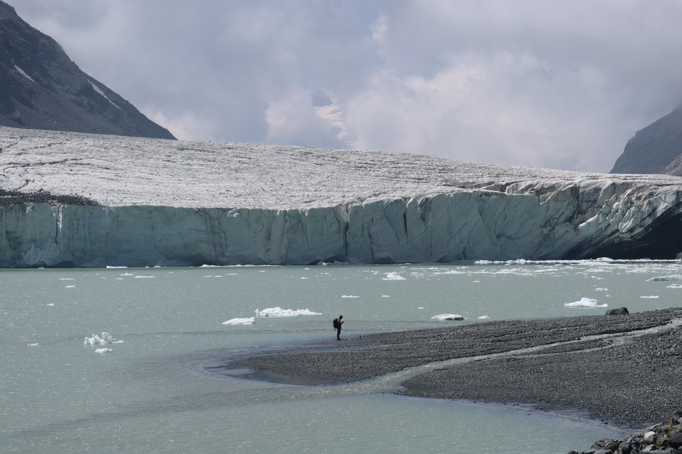

MOUNTAIN WILDERNESS INTERNATIONAL(ASIAN DESK)
CAAI - ACADENMIC ALPINE CLUB OF ITALY
ISMEO - INTERNATIONAL INSTITUTE FOR MEDITERRANEAN AND ORIENTAL STUDIES
MOUNTAIN WILDERNESS PAKISTAN
Invitation to apply for registration to a series of adventure hikes.
August/September 2022.
INTRODUCTION
Those who are used to surfing the site of Mountain Wilderness International already know or can learn about the purposes and different phases of what has been called The Swat Project. Suffice it to remind you that the Swat is a fascinating mountain region of Pakistan, easily reachable from the big cities of the plain and, for this reason, exposed to the risk of a disorderly growth of a basically aggressive, uneducated and disrespectful tourism. Mountain Wilderness believes that the only way to preserve the precious integrity of those valleys of magical beauty lies in the establishment of a national park. The route designed to get there passes through three successive steps.
- The exploration and description of possible trekking itineraries in the area’s principal mountain valleys, overlooked by peaks of up to 6000 metres, and verification of the mountaineering potential of the main mountains of the area. A first choice of trekking itineraries were successfully explored in the years 2019 and 2021 by small groups of Mountain Wilderness members and supporters. They hiked successfully along some different and very rewarding itineraries, crossing passes even over 4500 meters and in some cases negotiating crevassed glaciers. The undertaking included the identification of access routes to the major summits and photographic documentation of the followed itineraries. These initial explorations did not exhaust the trekking/mountaineering potential of the upper Swat, thus a third phase has been planned for the current year. This time also some mountaineering light expeditions are planned.

Collation of the material produced during those explorations and publication of a printed guidebook in English and Urdu with a clear environment- friendly suggestions and sound ethical character. The book will also include itineraries for visiting the “romantic” ruins of the Buddhist monuments tucked away among the lower Swat valleys.

- Development of the "National Park" project to be submitted for approval and implementation to the Government of Pakistan.
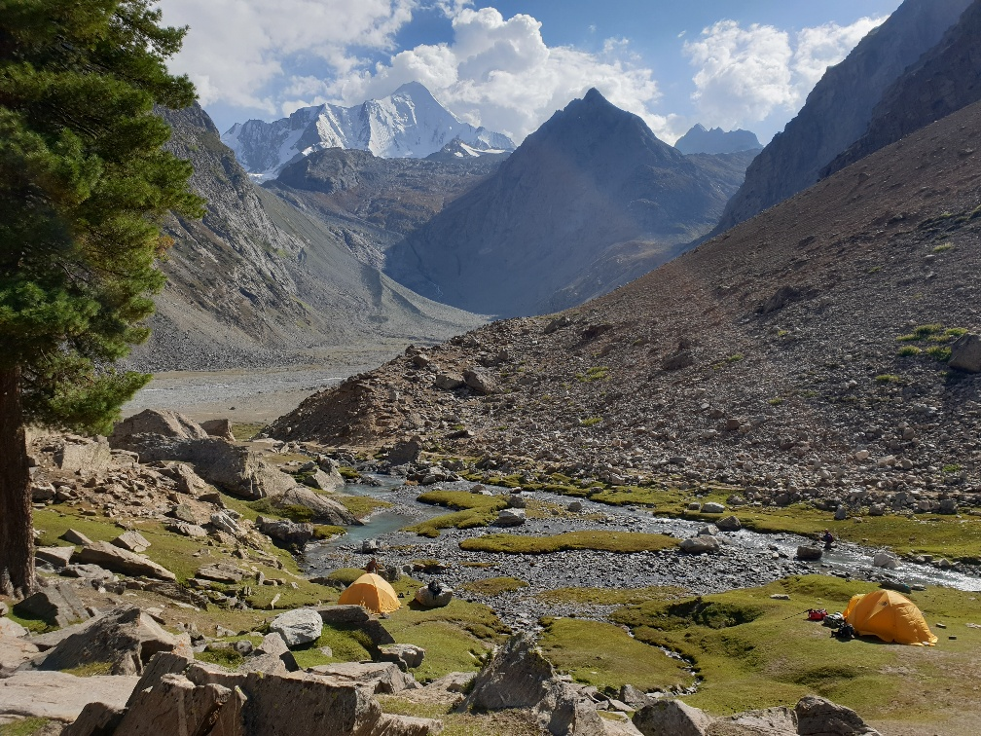

INVITATION
We propose to the members of the national Chapters of MW, to the members of Alpine Clubs, to Mountaineering schools and to all trekkers and mountain lovers to participate to the exploration and to the accurate description of potential trekking itineraries as " paying guests". An exciting experience, free from any risk due to political instability or fundamentalist upheavals. An authentic adventure, to identify routes that are often still completely unknown and therefore cannot be fully planned in advance. To the enthusiasm for the discovery of deserted valleys, passes, glaciers, must be added and taken into account also the possibility of some withdrawal ( or last minute changes) due to obstacles that could turn out to be too difficult. Some of the routes may require the crossing of glaciers and the consequent use of crampons, ice axe and rope. Those who wish to take part in the project may specify their willingness to face this type of difficulty. There are itineraries less demanding but equally fascinating. However, the following are indispensable: ability to adapt, spirit of adventure, awareness of the meaning of the project and its ethical/environmental value, willingness to describe in detail the path covered. Basic knowledge of the English language would be useful.
Duration: considering the morphology of the area, no route will last less than 7 hiking days. Calculate at least two full weeks in total. It is also possible to devote a day to visit the fascinating ruins of the ancient Buddhist monuments that dominate the hills of the southern part of the Swat region.
Each group will consist of four westerners in good physical shape, one or two former local assistants previously trained by Mountain Wilderness, a keeper of the camp, a cook, about 15 porters. Departures are planned between the 15th and the 30th of August. Enrolment will be opened in the 2nd of April and will last until the end of May. Mountain Wilderness will grant to the first eight enrolled participants a bonus of 100 euros. Mountain Wilderness, the Italian Academic Alpine Club and ISMEO entrusted the organization entirely to the Pakistani travel agency ATP which assumes full responsibility for every aspect, including insurance for porters and staff. ( see attached enrolment document).
For their part, participants must formally commit themselves to providing a detailed description of the itineraries, depicting their features, their altitude difference, their duration, stage by stage and accompanying the text with photographs.
To avoid any misunderstanding: those who participate should not be considered as passive customers who claim to be entitled to a full service from the organizing local agency. Tasks such as the choice of where to pitch a camp, assemble and disassemble tents, must be made actively and in good harmony by each member of the group, whether European or Pakistani.
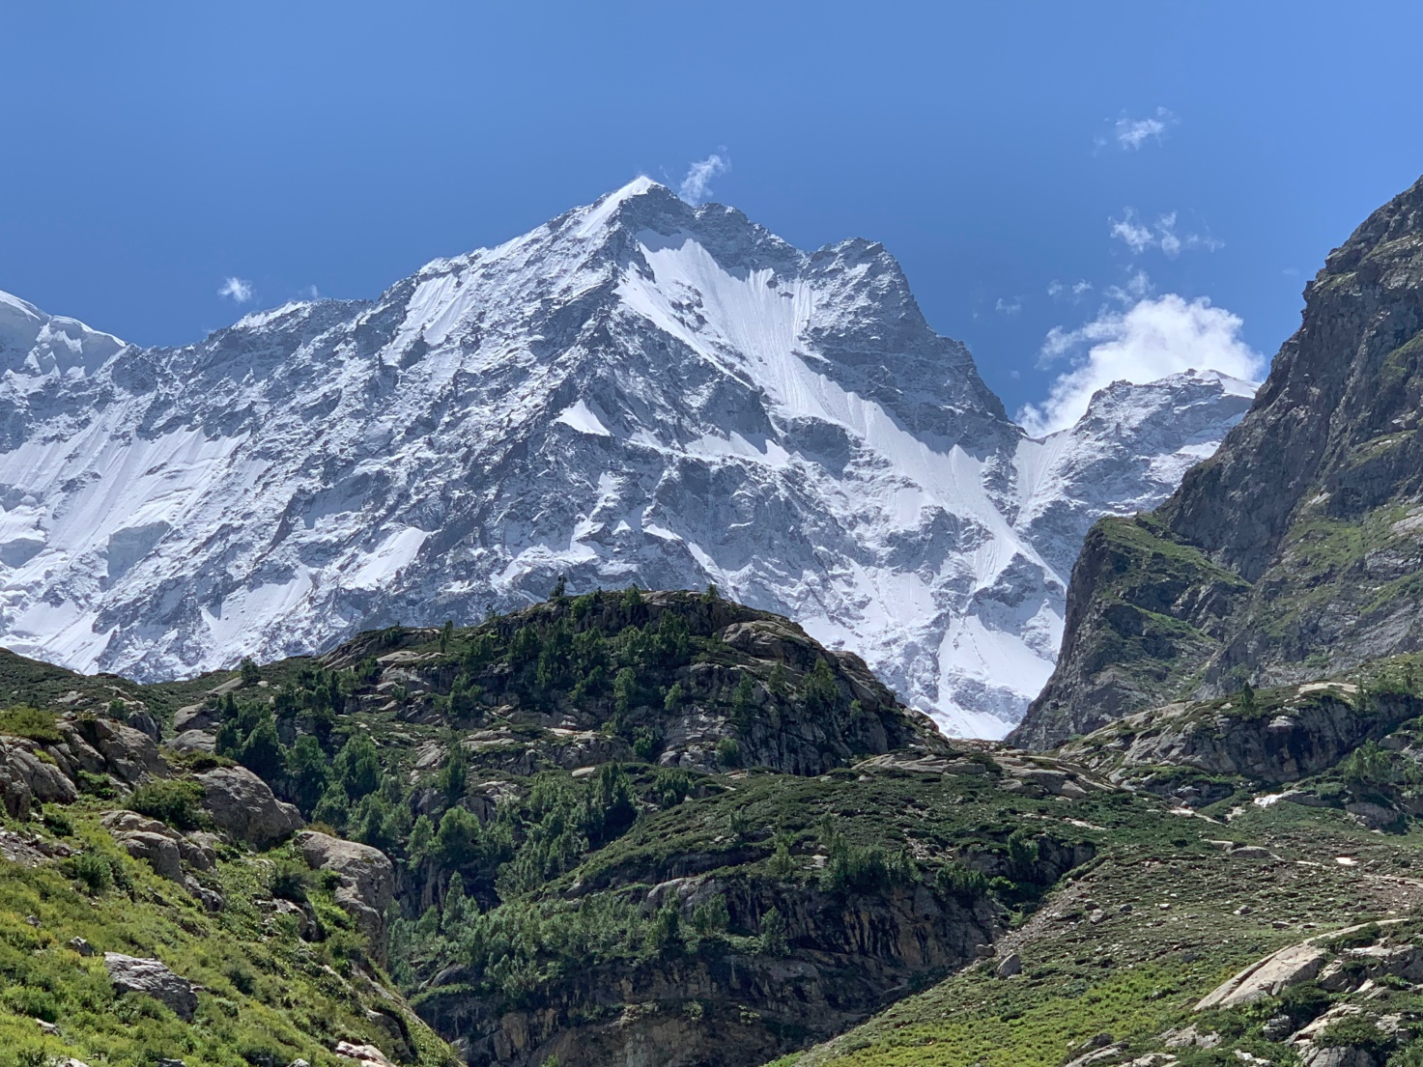
Those who are potentially interested are kindly requested to express their availability in principle by sending an e-mail to: bettopinelli@gmail.com.
Attached Enrolment document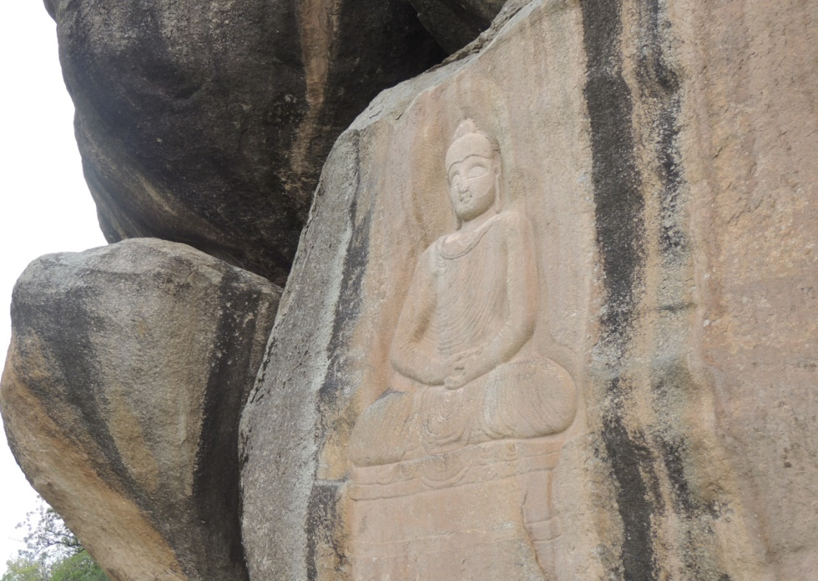

ADVENTURE TOURS PAKISTAN
Leading DMC & Tour Operating Company in Pakistan
Office 303, Chenab Center, 104-E, Jinnah Avenue
Blue Area, Islamabad, Pakistan
Phone: +92-51- 2348666/67 Fax: +92-51-2348667
Email: info@atp.com.pk, Website: www.atp.com.pk
Skype: adventuretours.pakistan )

THE SWAT PROJECT

ENROLMENT FORM

I, the undersigned………………………………………………….
Born (place of birth)……………………………..
On (date of birth) ……………………………………….
Resident at (home address……………………………………….
Telephone…………………………….. E-mail…………………….
Member of the association (optional)……………………………….
Passport number and dates:……………………………………………

Having carefully read the description of the Swat Project (Pakistan) announced by Mountain Wilderness International, the Italian Academic Alpine Club ( CAAI) and ISMEO ,
Aware that the initiative has been entrusted by Mountain Wilderness International ( Asian Desk), CAAI and ISMEO entirely to Adventure Tours Pakistan, which assumes full responsibility for every aspect, including insurance for staff and porters, to take place on Pakistani soil,

Aware that participants must take care of personal insurance by themselves,

Aware that, in this phase of the project, Mountain Wilderness , CAAI and ISMEO will have the sole role of technical/scientific consultants to ATP,

Mindful that the sum to be paid to the ATP Agency excludes the cost of airline tickets, consular visa, and personal insurance, will be equal to 1700 euros (with the minimal variations possible) for each pax,

Aware that each participant is expected to reach Pakistan by his/her own means and under his/her personal responsibility on a date to be agreed with the Agency itself,

Aware that the ATP will allow the participation ONLY of persons vaccinated against the Covid-19 virus

With the present form I express my intention to enrol in the initiative, and agree to send a security deposit of 300 euro by the end of June 2021 to the Adventure Tours Pakistan Agency( or to its agent in Europe), which will be returned to me up to 15 days before departure in the case I withdrawal for reasons demonstrable as beyond my control (force majeur), or in case the Government of Pakistan will oblige foreigners entering in the country to undergo a period of quarantine, also if vaccinated.
I hereby declare that I (cross out those that apply):
- Have been vaccinated against the Coronavirus 19
- Am scheduled to be vaccinated in the near future

I attach a brief curriculum vitae that makes particular reference to my previous trekking and mountaineering experience.

Signed (Signature and date)

